**1. What are escape characters, and how do you use them?**

Escape characters are used to represent charactrers in string values which are otherwise impossible to type in code. Ex. newline, backspace, tab spaces

**2. What do the escape characters n and t stand for?**

\n : newline

\t: tab

**3. What is the way to include backslash characters in a string?**

To include backslash \\ is used.

**4. The string "Howl's Moving Castle" is a correct value. Why isn't the single quote character in the word Howl's not escaped a problem?**

It s so because we have used double quotes to mark the starting and end of the string. And between double quotes a single quote can be written and vice-versa without error

**5. How do you write a string of newlines if you don't want to use the n character?**

We can use multiline string ‘’’….’’’ to perform the given task.

**6. What are the values of the given expressions?**

**'Hello, world!'[1]** = ’e’

**'Hello, world!'[0:5]** = ’Hello’

**'Hello, world!'[:5]** = ’Hello’

**'Hello, world!'[3:]** = 'lo, world!'

**7. What are the values of the following expressions?**

**'Hello'.upper()** = ‘HELLO’

**'Hello'.upper().isupper()** = True

**'Hello'.upper().lower()** = ‘hello’

**8. What are the values of the following expressions?**

**'Remember, remember, the fifth of July.'.split()** =['Remember,', 'remember,', 'the', 'fifth', 'of', 'July.']

**'-'.join('There can only one.'.split())** = 'There-can-only-one.'

**9. What are the methods for right-justifying, left-justifying, and centering a string?**

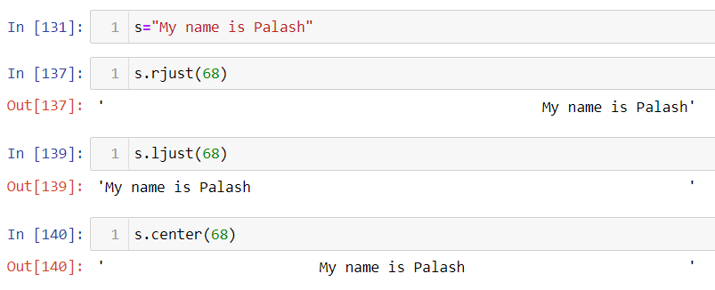

**10. What is the best way to remove whitespace characters from the start or end?**

lstrip(),rstrip() methods

